Coding Standards

Senior Design Project 2019

JavaScript Games

1. Minimize the use of global variables
2. Spacing
   1. All functions, for / while loops, if statements should be spaced in the same way
   2. At least one line between each “chunk” of code
      1. Ex: 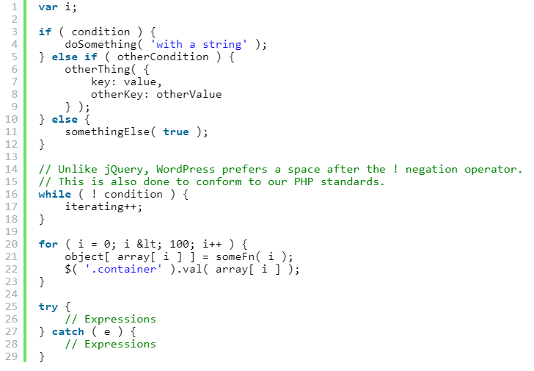
   3. If, else, for, while and try should always include braces and maintain appropriate spacing
3. Declaring Variables
   1. Declare variables in a single line of code.
      1. Grouped variables
      2. Variables equaling the same thing
4. Name Convention
   1. Make sure that the function or variable name makes sense and is understandable to what it is there for.
   2. Make sure not to use similar names in different functions to avoid confusion
5. Comments
   1. Before the “Chunk” of code
   2. Each class and function should have a section of comments above it
      1. Author
      2. Description
      3. Date of last updated
   3. If something was found or changed, the comment should be updated to reflect changes.
   4. A function or class does not need a comment if its functionality is evident.
6. Check Statement Conditions
   1. Always have the variable on the right hand side and the constant on the left
7. References
   1. If code is found or used it should be credited by that person.
      1. Include where it was from and how you used it.